Name: Bilal abid abbasi
Id:45961
Lab task 4

- Employee Management System

#include <iostream>
using namespace std;
class Employee {
private:
int employeeID;
string name;
string department;
double salary;
public:
void setEmployeeID(int id) {
employeeID = id;
}
void setName(string n) {
name = n;
}
void setDepartment(string dept) {
department = dept;
}
void setSalary(double sal) {
salary = sal;
}
int getEmployeeID() {
return employeeID;
}
string getName() {
return name;
}
string getDepartment() {
return department;
}
double getSalary() {
return salary;
}
};
int main() {
Employee emp1;
// Setting values
emp1.setEmployeeID(101);
emp1.setName("Bilal");
emp1.setDepartment("IT");
emp1.setSalary(50000);
cout << "Employee Details:\n";
cout << "ID: " << emp1.getEmployeeID() << endl;
cout << "Name: " << emp1.getName() << endl;
cout << "Department: " << emp1.getDepartment() << endl;
cout << "Salary: " << emp1.getSalary() << endl;
return 0;
}
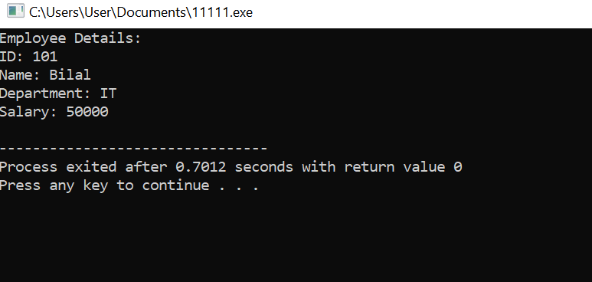

2. Library Book Management System

#include <iostream>
using namespace std;
class Book {
private:
string title;
string author;
string ISBN;
string availabilityStatus;
public:
void setTitle(string t) { title = t; }
void setAuthor(string a) { author = a; }
void setISBN(string i) { ISBN = i; }
void setStatus(string s) { availabilityStatus = s; }
string getTitle() { return title; }
string getAuthor() { return author; }
string getISBN() { return ISBN; }
string getStatus() { return availabilityStatus; }
};
int main() {
Book books[3];
for (int i = 0; i < 3; i++) {
cout << "\nEnter Book " << i + 1 << " Details:\n";
string title, author, isbn;
cout << "Title: ";
cin >> title;
cout << "Author: ";
cin >> author;
cout << "ISBN: ";
cin >> isbn;
books[i].setTitle(title);
books[i].setAuthor(author);
books[i].setISBN(isbn);
books[i].setStatus("Available");
}
cout << "\nLibrary Books:\n";
for (int i = 0; i < 3; i++) {
cout << "\nBook " << i + 1 << endl;
cout << "Title: " << books[i].getTitle() << endl;
cout << "Author: " << books[i].getAuthor() << endl;
cout << "ISBN: " << books[i].getISBN() << endl;
cout << "Status: " << books[i].getStatus() << endl;
}
return 0;
}

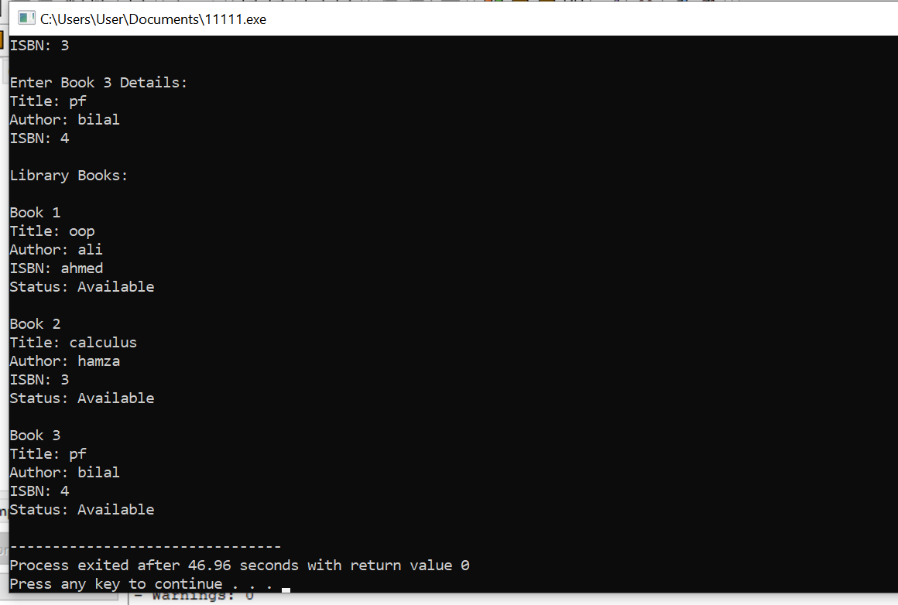

3.Bank Account System

#include <iostream>
using namespace std;
class BankAccount {
private:
int accountNumber;
string accountHolderName;
double balance;
public:
void setAccountNumber(int accNo) {
accountNumber = accNo;
}
void setAccountHolderName(string name) {
accountHolderName = name;
}
void deposit(double amount) {
balance += amount;
cout << "Amount Deposited Successfully!\n";
}
void withdraw(double amount) {
if (amount > balance) {
cout << "Insufficient Balance!\n";
} else {
balance -= amount;
cout << "Withdrawal Successful!\n";
}
}
void displayDetails() {
cout << "\nAccount Details:\n";
cout << "Account Number: " << accountNumber << endl;
cout << "Name: " << accountHolderName << endl;
cout << "Balance: " << balance << endl;
}
};
int main() {
BankAccount acc1;
acc1.setAccountNumber(12345);
acc1.setAccountHolderName("Bilal");
acc1.deposit(10000);
acc1.withdraw(3000);
acc1.displayDetails();
return 0;
}

